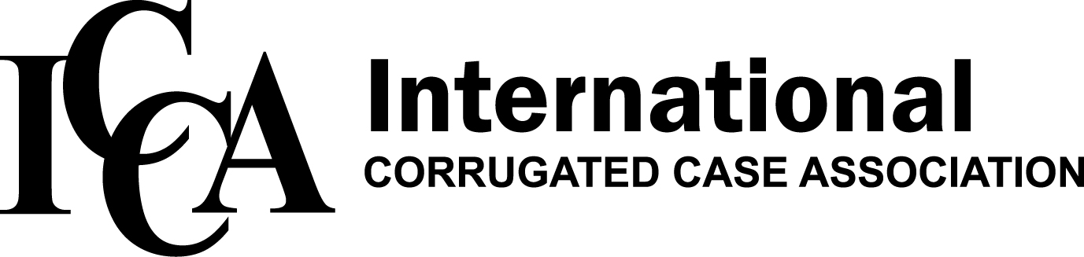 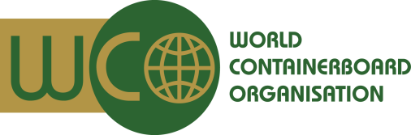

**FOR IMMEDIATE RELEASE**

September 24, 2014

For more information, contact Rachel Kenyon at [rkenyon@iccanet.org](mailto:rkenyon@iccanet.org) or 847-364-9600.

**ICCA and WCO ANNOUNCE 2015 GLOBAL**

**SUMMIT DATES; OPEN REGISTRATION**

The International Corrugated Case Association (ICCA) and the World Containerboard Organisation (WCO) are pleased to announce the 2015 ICCA/WCO Global Summit will be held April 13 – 17, 2015 in Taipei and Shanghai.

The Global Summit kicks-off in Taipei, Taiwan April 13 – 15, at the Grand Hyatt, a five-star rated best in Taipei hotel adjacent to the famous Taipei 101 building. Hosted by Cheng Loong, the event will include general meeting sessions, networking and social events including a full program of spouse/companion tours.

From there, the Global Summit continues April 16 – 17, in Shanghai, China at the Mandarin Oriental, another five-star rated best new hotel. In cooperation with Reed Exhibitions and SinoCorrugated, ICCA/WCO Global Summit attendees will be treated to a VIP tour of the exhibition, a tour of Cheng Loong’s mill and box plant in Shanghai and a river/dinner cruise. SinoCorrugated is the largest corrugated equipment manufacturers’ trade show in the world and is expected to attract more than 25,000 attendees in 2015.

The Global Summit brings together containerboard and corrugated industry leaders from around the globe. The 2015 event builds on the success of previous Summits held in Sydney, Australia, Tokyo, Japan, Montreal, Quebec, Canada and most recently Paris, France.

Don’t miss your chance to participate in this exciting event. To register visit the ICCA website, [www.iccanet.org](http://www.iccanet.org),

# # #